Comprehensive range of robust Carbon Brush Holders to go with carbon brush technology for use in motors and generators to industries like Sugar Industries, Steel processing, Mining Industries, Power generation Industries, Traction and a wide range of general industrial applications.

All our Holders are made of finest quality Brass, sheet or solid with constant pressure spring assemblies. Specialized options include height adjustability, brush wear devises, quick disconnect terminals and low friction coatings.
Our Holders are engineered with exclusive features that help to extend Brush life, improve equipment performance, minimize downtime and reduce maintenance expenses.
The use of proper constant force springs can be a significant advantage with consistent minimal wear rate of the brushes, reduced where of the contact surface, less carbon dust, and much lower overall maintenance cost on the unit. We haves an extensive product portfolio to support your current and future motor and generator requirements including:
Whatever your requirements we will work closely with you to offer an engineered solution.
For further information on our extensive range of brush holders please contact us today.

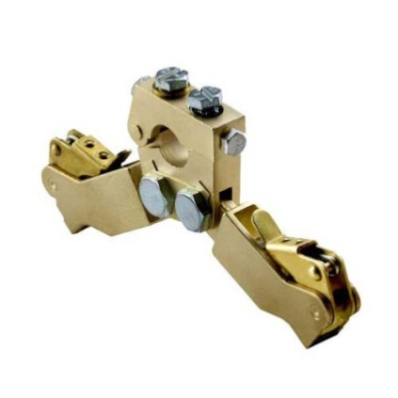 | 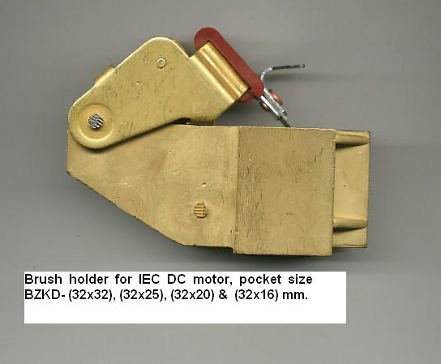
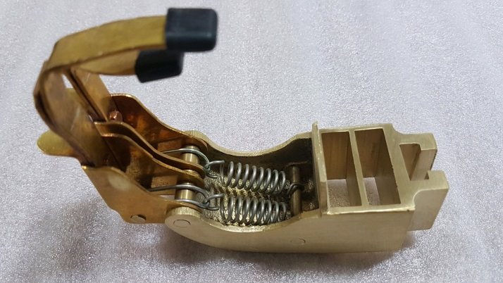 | 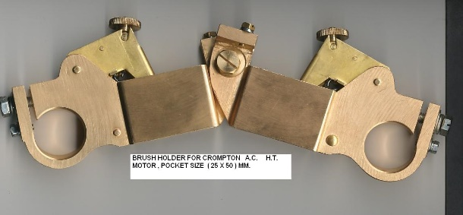
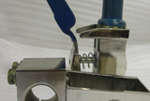 | 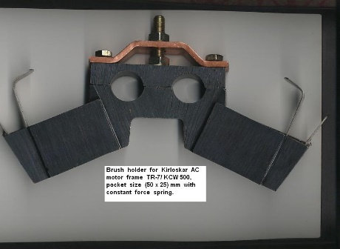
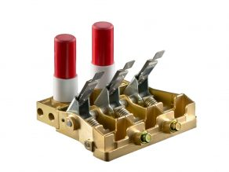 | 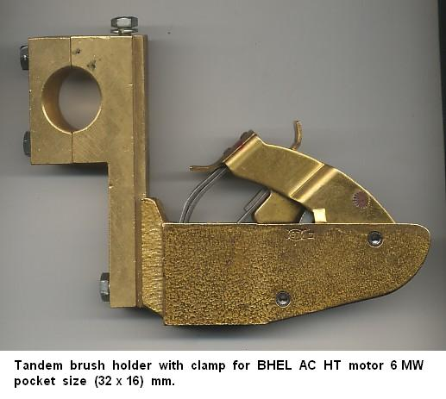
 | 